Custom Packaging Optimization for Cardboard Waste Reduction Using AI-Driven Techniques
Prerna Sharma
Department of Computer Science Chitkara University
Email: prerna2086.be22@chitkara.edu.in

Abstract—The exponential growth of online retail operations has led to massive amounts of packaging waste caused by inadequate box size design and overprotection of goods during shipping. Consequently, high logistical and environmental im-pacts have been incurred. To mitigate such issues, an AI-powered optimization scheme for generating custom-fit packaging designs is presented in this study.
In particular, the proposed scheme uses a clustering algorithm that is based on machine learning to divide products into clusters according to their similarities regarding physical properties. Then, a dynamic programming algorithm is used to find the optimal box size parameters and minimize unnecessary material consumption. Constrained optimization is introduced to account for real-world limitations, such as product protection and weight distribution.
To evaluate the proposed algorithm, a dataset with 8,947 unique items was created and analyzed using the proposed and baseline algorithms. Statistically, the algorithm outperformed the baseline fixed-margin approach by significantly reducing material usage and carbon footprint, which is associated with lower costs. Overall, the results demonstrate the effectiveness of artificial intelligence, optimization approaches, and informed decision-making in facilitating sustainable packaging solutions for contemporary e-commerce operations.
Index Terms—E-commerce, Packaging Optimization, Machine Learning, Dynamic Programming, Constrained Optimization, Sustainability, Supply Chain Management, Carbon Emission Reduction

- Introduction
The rapid rise of e-commerce has revolutionized retailing, but this process comes at the cost of the ever-growing amount of packaging waste, especially related to the use of corrugated cardboard boxes. In most current packaging processes, a fixed-margin approach to sizing a box is employed. According to this approach, the predetermined sizes of boxes are utilized in-dependent of the exact dimensions of products. The simplicity of using fixed margins makes this approach popular; however, it typically results in the significant amount of unused spaces inside packages. Thus, besides the additional transportation costs and environmental impacts, such packaging processes lead to the overuse of resources and materials [11].
Considering the growing concerns about the sustainability of the economy and the environmental impact, there is a compelling need for more effective packaging approaches. One should note that recent advances in AI and optimization technologies have generated many innovative approaches [9]. Through the implementation of these approaches, packaging
processes will be able to become much more efficient. Specif-ically, through the use of artificial intelligence, packaging processes may become much more flexible and adaptive to the properties of products.
We present here an AI-based framework for customization in packaging that seeks to reduce wastage of cardboard by optimizing cardboard usage while being feasible and safe for the items packaged. This approach combines machine learning and optimization techniques to create optimal packaging.
The key contributions of this work are as follows:
- Development of a machine learning-based clustering ap-proach for grouping products based on dimensional and structural similarity
- Implementation of a dynamic programming model for optimal volume and box dimension selection
- Formulation of a constrained optimization problem for designing safe and efficient packaging solutions
- Comprehensive evaluation using metrics such as material usage, cost efficiency, and carbon emission reduction
- Statistical validation to demonstrate the significance and robustness of the proposed approach
- Related Work
The optimization of packaging has long been a subject of in-terest in operations research. In this regard, various models and solutions have been proposed, such as the popular bin packing problem and container loading problem [1], [12]. These often relate to the underlying complexities found in knapsack-style problems [5]. In these formulations, the goal is to minimize the wasted space when packing objects within a container. Despite being powerful tools in the theoretical setting, classical approaches usually operate under the assumption of known input values that remain unchanged throughout the process.
More recently, data-driven methods have been considered as an approach to solve the above problem. Clustering methods such as K-Means are often utilized to classify items based on their similar dimensions and shapes [2], [6]. Performance measures like the silhouette score are often calculated to eval-uate clustering performance and ensure reasonable clustering outcomes.
From a sustainability standpoint, the packaging process can be optimized by performing life cycle assessments (LCAs) that take into account the environmental impacts during production, consumption, and end-of-life phases [3], [7]. The methods are

insightful, but they are generally not employed for optimiza-tion purposes.
Gradient descent algorithms like L-BFGS-B have been extensively utilized for solving constrained nonlinear pro-gramming problems [4], [8]. Although the methods men-tioned above work well, previous studies view clustering, optimization, and sustainability as isolated concepts without considering the possibility of incorporating all three elements into an intelligent packaging optimization approach.
- Methodology
- System Architecture
  - Eliminating observations where information was missing
  - Eliminating observations with invalid dimensions that are less than or equal to zero
  - Changing units of observation to standard units
Volume calculation was done using the following equation:
V = L × W × H (1)
C. Scaling of Features
To allow each feature to have equal importance in clustering, standardization is used as follows:

The proposed architecture is composed of several modules that perform specific tasks including Data Ingestion, Prepro-
x − µ
z =
σ
(2)

cessing, and a Clustering Engine. This architecture aligns with modern Cyber-Physical Systems (CPS) and Industrial IoT frameworks used in smart logistics [10].
  - Data Ingestion Module: The module that ingests raw data concerning the dimension of the products into the system.
  - Data Preprocessing Module: The module that cleanses the data before employing it within the optimization process.
  - Clustering Engine: The module that clusters products into groups based on similarity through K-Means clus-tering algorithm.
  - Volume Calculation Module: The module that calculates the volumes of the products in addition to similarity-based volume estimation.
  - Optimization Module: This module determines the op-timal box dimensions under specific restrictions.
  - Evaluation Module: This module evaluates the output produced by the optimization module based on appro-priate measures like wastage, cost, and environmental impact.
The workflow of the suggested framework is shown in Fig. 1.
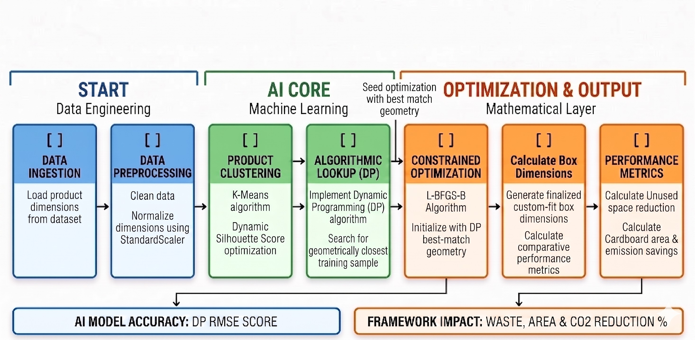

Fig. 1.

- Data Preprocessing
At the start, the dataset consisted of 9,618 items on e-commerce. Following the cleaning step, only 8,947 obser-vations remained. Steps involved in the preprocessing stage include the following:
This removes any preference for higher numerical values.
- Clustering via K-Means
The K-Means clustering technique is used for clustering of products on the basis of dimensional attributes to minimize computational difficulty, following the foundations established by MacQueen [6]. Cluster validation is performed by calcu-lating silhouette coefficient values [2].
Cluster validation is performed by calculating silhouette coefficient value using the following equation:
b(i) − a(i)
s(i) = (3)
max(a(i), b(i))
In which a(i) stands for intra-cluster distance whereas b(i)
stands for nearest-cluster distance.
- Estimating Volume through Similarity
In order to make more informed decisions in packaging, it becomes necessary to use a nearest neighbor method to find packages that share the same dimensions. The Euclidean distance is calculated by means of Equation 4.
d_{i} = √(h_{i} − h)2 + (w_{i} − w)2 + (l_{i} − l)2 (4)
The nearest neighbor package may then be used as a basis in estimating packaging materials needed.
- Optimization Problem
The mathematical formulation of the above stated optimiza-tion problem is shown below in order to minimize the quantity of material used in building the box.
min V_{box} = L × W × H (5) With the condition:

L ≥ l + m (6)
W ≥ w + m (7)
H ≥ h + m (8)
(9)
Where l, w, and h denote the dimensions of the object while m denotes 2 cm.

- Optimization Algorithm
In light of the prevailing scenario, it will be appropriate to observe that the L-BFGS-B optimization algorithm has been effectively implemented. This approach is grounded in numerical optimization theories for bound-constrained prob-lems [4], [8]. However, in case implementing the optimization algorithm becomes a challenging affair, it will be better to apply the quasi-Newton optimization algorithm. In case there is the challenge of insufficient space in the memory when implementing the optimization algorithm, then it will be necessary to approximate the Hessian matrix.
The formula to be used when computing the optimization parameter is presented as follows:
- Evaluation Criteria
The list of criteria for assessment includes the following: efficiency, cost-effectiveness, environmental factors related to using of the algorithm.
- Waste reduction
In case of any waste created during packaging of goods, it should be regarded as unutilized volume of a box:
Waste = V_{box} − V_{product} (13)
Relative reduction of this type of waste compared to the base value is calculated according to the formula:
Waste_{b} − Waste_{o}

x_{k+1} = x_{k} − α_{k}H_{k}∇f (x_{k}) (10)
Reduction% =
Waste_{b}
× 100 (14)

From the formula presented above, it can be observed that H_{k} approximates the Hessian matrix while α_{k} indicates the step size.
Some of the attributes associated with the algorithm are listed as follows:
- Fast convergence,
- Solving the constraint problem, and
- Data processing.
- Feasibility Verification of Packaging Candidates
For verifying the safety of the selected packaging candi-dates, the following aspects should be considered to establish whether they can be adopted:
  - Minimum Margin Condition: The condition of mini-mum margin for the product in relation to the inner walls of the container.

Aspect Ratio Condition:
max(L, W, H) ≤ 5 (11)
min(L, W, H)
The above aspects will prevent the selection of infeasible packaging candidates.
- Benchmarking
A benchmark was established based on the classical method of fixed margin packaging:
In which the values Waste_{b} and Waste_{o} denote wasted volume in base and proposed scenarios respectively.
- Cost model
The cost of packing depends on its volume directly:
Cost = V_{box} × c (15)
In which c = 0.002 $/cm³ stands for packaging material price.
- Carbon dioxide emissions
Another criterion for assessment of ecological effects will be the calculation of emissions due to packaging material use:
CO₂ = V_{box} × e (16)
In which e = 0.0005 kg CO₂/cm³ is an emission factor.
- Surface area
In order to evaluate another criterion for assessing material use it’s appropriate to estimate cardboard needed volume by calculating surface area:
A = 2(LW + WH + HL) (17)
- Volume Utilization
Volume utilization measures how efficiently the box space is used:

L_{b} = l + 6, W_{b} = w + 6, H_{b} = h + 6 (12)
U = Vproduct
Vbox
(18)

This formula represents the real conditions in the industry and may serve as a standard for the evaluation of the algorithm’s efficiency.
- Computational Complexity
The computational complexity of the system is analyzed as follows:
  - K-Means clustering: O(nkt)
  - Nearest neighbor search: O(n) per query
  - L-BFGS-B optimization: O(mn)
Overall, the framework is computationally efficient and suitable for large-scale e-commerce datasets.
Higher utilization values indicate better space efficiency and reduced waste.
- Results and Analysis
- Results of Quantitative Analysis
An analysis has been carried out to compare the optimized model of packaging process with the existing one where margins remain fixed. Certain improvements are obtained in the new model relative to the baseline, which are presented in Table I.
It is clear from the table above that a great amount of waste reduction and utilization has been gained in the new model.

TABLE I
Baseline vs Optimized Packaging Model

Parameter  Waste Space | Baseline  - | Optimized  68.94%
Cost | - | 13.26%
Carbon Emission | - | 13.26%
Surface Area | - | 12.74%
Utilization Efficiency Low 51.67%

- Graphical Representation of Results
Figure 2 shows a graphical presentation of the findings for waste, cost and carbon emissions. The performance of the new model has been found significantly better than the baseline model for all criteria.
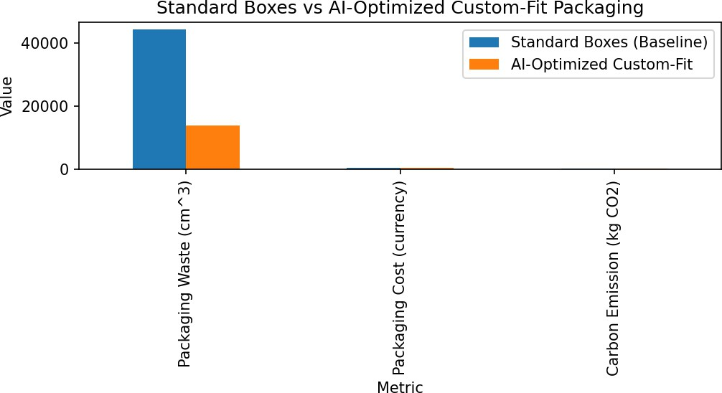

Fig. 2. Comparison between waste, cost and carbon emissions.

- Packaging Waste Distribution
The comparison between the packaging waste distribution before and after the optimization process is presented in Fig. 3. The analysis shows that the use of the optimization method led to the appearance of an evident trend towards a lower level of waste, meaning that there was a higher efficiency in using the packaging capacity.
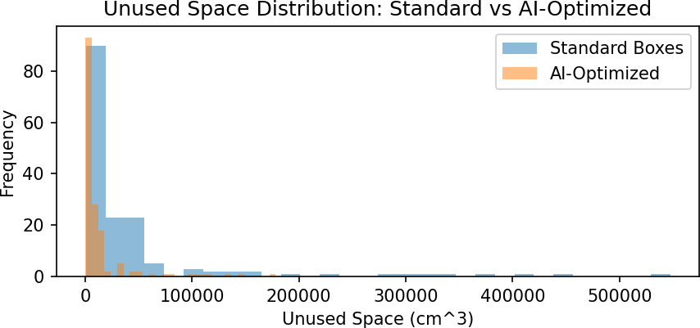

Fig. 3. Packaging waste distribution.

- Accuracy of Prediction
The dependence of actual product volume on its forecasted value is plotted in Fig. 4. One may notice that the scatter plot demonstrates a good correlation between these two parameters,
which indicates a sufficiently high prediction accuracy of the proposed model.
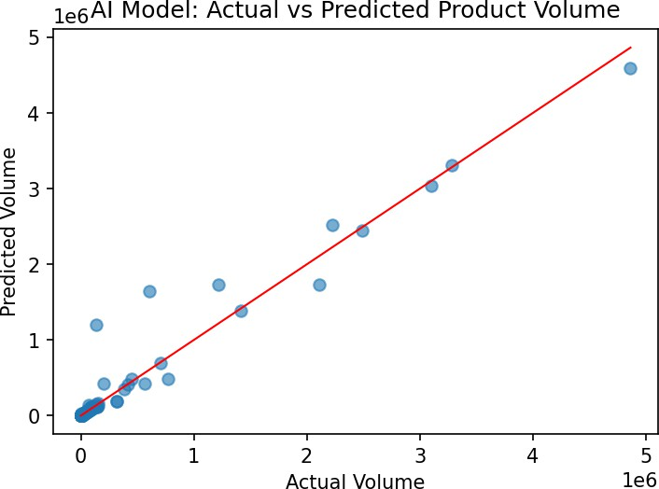

Fig. 4. Actual vs predicted product volume.

- Statistical Validation
In order to confirm the validity of the results obtained, several types of statistical tests have been used. Paired t-test gives p < 0.05, which proves the significance of changes obtained. Furthermore, there is no need to assume the normal distribution of results for the analysis performed by means of the Mann-Whitney U test. The size of Cohen’s d shows a high effect size.
- Discussion
The increase in efficiency is a result of the combination of both clustering and optimization. Grouping items according to dimensions increases consistency and allows for more accurate packing. Optimization through minimization of volume under certain constraints leads to removal of excessive margins.
The considerable decrease in waste percentage (68.94%) proves that the approach is effective in solving one of the main problems of traditional packaging systems. The correlation between the decrease in waste, cost, and carbon emissions shows that the two goals are highly intertwined.
The improvement in the utilization of volume (51.67%) means greater spatial efficiency that will have positive con-sequences for other stages of logistics. The results suggest that the suggested model is not only scalable but practical.
In summary, the paper proved that integration of artificial intelligence and optimization leads to positive changes in packaging efficiency, economy, and sustainability.
- Discussion
The suggested solution proves that the use of AI and optimization methods in e-commerce is highly effective for improving the packaging process. The integration of clustering and optimization provides great opportunities to overcome some problems associated with traditional packaging strate-gies.

- Comparison with Traditional Approaches
The most common packaging technique used by companies today involves predefining box sizes without considering the difference between the dimensions of various goods. As a result, there is too much leftover space and poor use of pack-aging materials. However, the suggested strategy uses variable box dimensions depending on the products’ characteristics.
- Implementation
In the process of the design and implementation of the model, certain aspects need to be considered to make it more practical for actual use. It will assist the warehouse systems of various online retailers in choosing the best packing options. Moreover, the model can work hand-in-hand with automated packaging systems, where intelligent packing machines and robotized packaging will be used. Besides, the application of the proposed model may prove useful in logistics and supply chain management, making it easier to store, transport, and manage goods.
- Environmental Effect
Since there will be less packaging material involved, there will also be positive effects on the environment. They include:
  - Reduction of the carbon footprint involved in the manu-facture and transport of the extra packaging material
  - Relief from natural resource strain, particularly deforesta-tion
  - Support for sustainability efforts in logistics and supply chain management
- Limitations and Future Scope
However, despite the high efficiency of the suggested ap-proach, there exist some restrictions that limit its further improvement. Firstly, it should be noted that at the moment, the objects under consideration are considered to be of the rectangular form, whereas no consideration is given to possible alternative geometric forms of objects. Secondly, the impact of the environment on objects is not taken into account.
The future development of the suggested approach may include the following elements: taking into account the true shape of objects, using sensors for real-time monitoring, and utilizing machine learning techniques.
- Limitations
Although the suggested system has shown outstanding per-formance, there are some limitations associated with it that need to be taken into account while analyzing the results.
- Strict Product Configuration: The proposed framework relies on the assumption that each product has its rigid rectangular shape. On the contrary, many products are non-rigid or have an irregular shape.
- Material Homogeneity: It is assumed that all material characteristics are the same for different products. For example, the strength or thickness of cardboard or another packaging material is always the same.
- Internal Materials Ignored: It is assumed that no cush-ioning is placed inside packages. As a result, some minor errors may occur in terms of calculating the necessary packaging space.
- External Constraints Ignored: There are other factors that influence packing optimization but are not incorpo-rated into the proposed system.
- High Dynamicity: The system works efficiently with static data sets. However, further improvements are re-quired in case of implementation within dynamic and highly scalable warehouses.

- Future Work
While the presented solution proves to be effective, there are a few approaches that can be applied in order to improve the performance of the framework.
- Better Learning Algorithms: Future development can involve implementation of more advanced types of learn-ing such as deep learning and reinforcement learning in order to increase the quality of predictions and adaptabil-ity.
- Deployment in Real-Time Environment: Development of a solution that will allow using the framework in real-time mode within warehouses or logistics centers and make use of live streams of data.
- Multi-Criteria Approach: Current research mainly con-centrates on reducing volume. Multi-criteria approach will allow to optimize multiple parameters such as price, carbon footprint, product longevity, and transportation efficiency at once.
- Non-Rectangular Products: Integration of additional mechanisms that will allow dealing with deformable products with irregular shapes.
- IoT and Robotics: Further development of the algorithm with IoT integration and automated packing systems.

- System Implementation and Execution
The developed system implementation takes place in the form of a pipeline consisting of several modules used to process data, perform machine learning operations, and con-duct optimization processes that lead to efficient packaging results. The modules are independently implemented and easily upgradable without impacting other parts of the system.

- Pipeline Description
Execution stages in the pipeline consist of:
  - Acquisition and preprocessing of data
  - Data scaling and normalization
  - Product classification using the K-Means clustering ap-proach
  - Prediction of volumes through similarity analysis
  - Optimization using the L-BFGS-B method
  - Performance evaluation and visualization

- Sequence of Steps to be Followed
This process can be explained step-wise as follows:
- Prepare the data through elimination of all errors from the data set
- Normalize the data set through scaling of size of each individual element
- Perform K-means clustering on similar elements
- Splitting of data set into two different data sets (training and testing)
- Finding out volume of product using the concept of similarity
- Optimization of size of packaging based on some con-straints
- Ensure that all constraints are satisfied
- Evaluate performance indicators
- Computational Efficiency
Regarding computational efficiency and scalability, one can state that the proposed product classification method exhibits its scalability to the growing number of samples and linear complexity of pre-processing data. Using the gradient-based L-BFGS-B optimizer, the fast convergence of the classifier on input data is guaranteed.
According to experiments, clustering of thousands of objects requires only less than a minute of time. Thus, the proposed approach can be regarded as computationally efficient and used in various scenarios.
- Implementation Details
Product classification solution is implemented in Python programming language and employs well-known libraries such as NumPy, Pandas, Scikit-learn, and SciPy. Clustering and optimization are performed using the L-BFGS-B optimizer for fast convergence. Visualization of results is provided by the Matplotlib library.
Integration of the proposed classifier in existing inventory management systems can be easily achieved.
- Sustainability Analysis
Environmental concerns related to packaging have increas-ingly come into focus in today’s online business world. In addition to being costly to the company’s operation, the exces-sive use of packaging material is also highly wasteful from an environmental perspective. Sustainability analysis is included in the proposed framework to calculate the environmental savings. As noted by McKinnon [11], carbon footprints in logistics are heavily tied to transportation volume and material weight. Through reducing the volume of packaging used, the proposed system manages to reduce the overall carbon footprint.
- Carbon Footprint
Carbon footprints resulting from packaging are expected to be directly proportional to the volume of packaging used:
CO₂ = V_{box} × e (19)
where e is the emission factor. Through reducing the volume of packaging used, the proposed system manages to reduce the overall carbon footprint. Furthermore, the decrease in transportation carbon emissions is also realized due to better use of space.
- Material Conservation
With effective packing of items, there will be a significant decrease in the use of material for packaging purposes. The following advantages accrue from using fewer materials. First, there will be conservation of natural resources such as paper pulp. Secondly, the amount of energy used in production will be lower since less processing will be involved. Thirdly, fuel expenses are lowered since there is less weight for transportation.
- Life Span Approach
From the point of view of the life span approach, the reduction of packaging materials affects several stages in the process, such as manufacturing, transport, and disposal. The fewer packaging materials used, the less waste there will be.
- Implications for Environment
Clearly, it can be noted that the suggested packaging model is advantageous from the standpoint of environmental effi-ciency, because due to the implementation of this system, more rational use of the materials used is ensured. Thanks to the optimization of packaging sizes and elimination of unnecessary spaces inside packages, this model provides an opportunity to reduce the consumption of packaging material, hence reducing the necessity of extracting wood pulp as raw material. Moreover, because of the reduction of the amount of material required to produce packaging, energy consumption is also going to be lower.
- Conclusion
The current paper has shown an Artificial Intelligence based method of optimizing package. This method resolves some of the problems related to optimal box sizing in e commerce platforms.
Machine learning algorithms and optimization models were used together to develop custom packaging that would be suitable for products sizes.
The analysis was done on a large-scale dataset. It revealed considerable progress achieved in reducing packaging waste, material consumption, costs and emissions.
So the research confirmed that limiting areas in packages does not only allow saving money and other resources but also helps to protect the environment.
The developed algorithm is highly scalable and efficient.
Therefore Artificial Intelligence based method can be used for application in the logistics industry.
It illustrates a way of making decisions based on big data analytics to build an intelligent and sustainable packaging strategy.
Artificial Intelligence based method is a way to make packaging better.

Future research aims at implementing the proposed model into advanced versions of packaging systems to account for different shapes of goods and other real-world factors.
References
- Coffman, E. G., Garey, M. R. And Johnson, D. S. “Approximation algorithms for bin packing: A survey,” in Approximation Algorithms for NP- Problems, D. Hochbaum, Ed., Boston: PWS Publishing Co., 1997
pp. 46–93.
- P. J. Rousseeuw, “Silhouettes: A aid to the interpretation and validation of cluster analysis,” Journal of Computational and Applied Mathematics, vol. 20 53–65, 1987.
- Hellweg, S. And Mil‘a i Canals, L., “approaches, challenges and oppor-tunities in life cycle assessment,” Science, 344(6188) pp. 1109–1113, May 2014.
- Byrd R.H., P. Lu, Jorge Nocedal and C. Zhu, “A limited memory algorithm for bound constrained optimization,” SIAM J. Sci. Comput., 16, no. 5 Pp. 1190–1208 1995.
- Martello, Silvano and Paolo Toth, Knapsack Problems: Algorithms and Computer Implementations, Chichester, UK: John Wiley & Sons 1990.
- J. MacQueen, “Some methods for classification and analysis of - variate observations,” in Proceedings of the 5th Berkeley Symposium on Mathematical Statistics and Probability, vol. 1 1967 Pp. 281–297.
- Finnveden, G., et al., “developments in Life Cycle Assessment,” Journal of Environmental Management vol. 91 No. 1 1–21, 2009.
- Nocedal, Jorge and Wright Stephen J., Numerical Optimization, second ed., New York, NY: Springer Science+Business Media, 2006.
- H. Min, “Artificial intelligence in supply chain management: theory and applications,” International Journal of Logistics Research and Applications, vol. 13, no. 1, pp. 13-39, 2010.
- Huang, G. Q., Zhang, M. And Zhang, L., “A framework for production-logistics systems based on CPS and Industrial IoT,” IEEE Trans. Ind. Inform., 15(9) 5337–5346, 2019.
- McKinnon, Alan, “CO₂ emissions from freight transport: an analysis of UK data,” Logistics Research, vol. 2 Issue 1 pp. 1–9, 2010.
- Pisinger, David (2002). “Heuristics, for the container loading problem,” European Journal of Operational Research, 141(2) 382–392.

